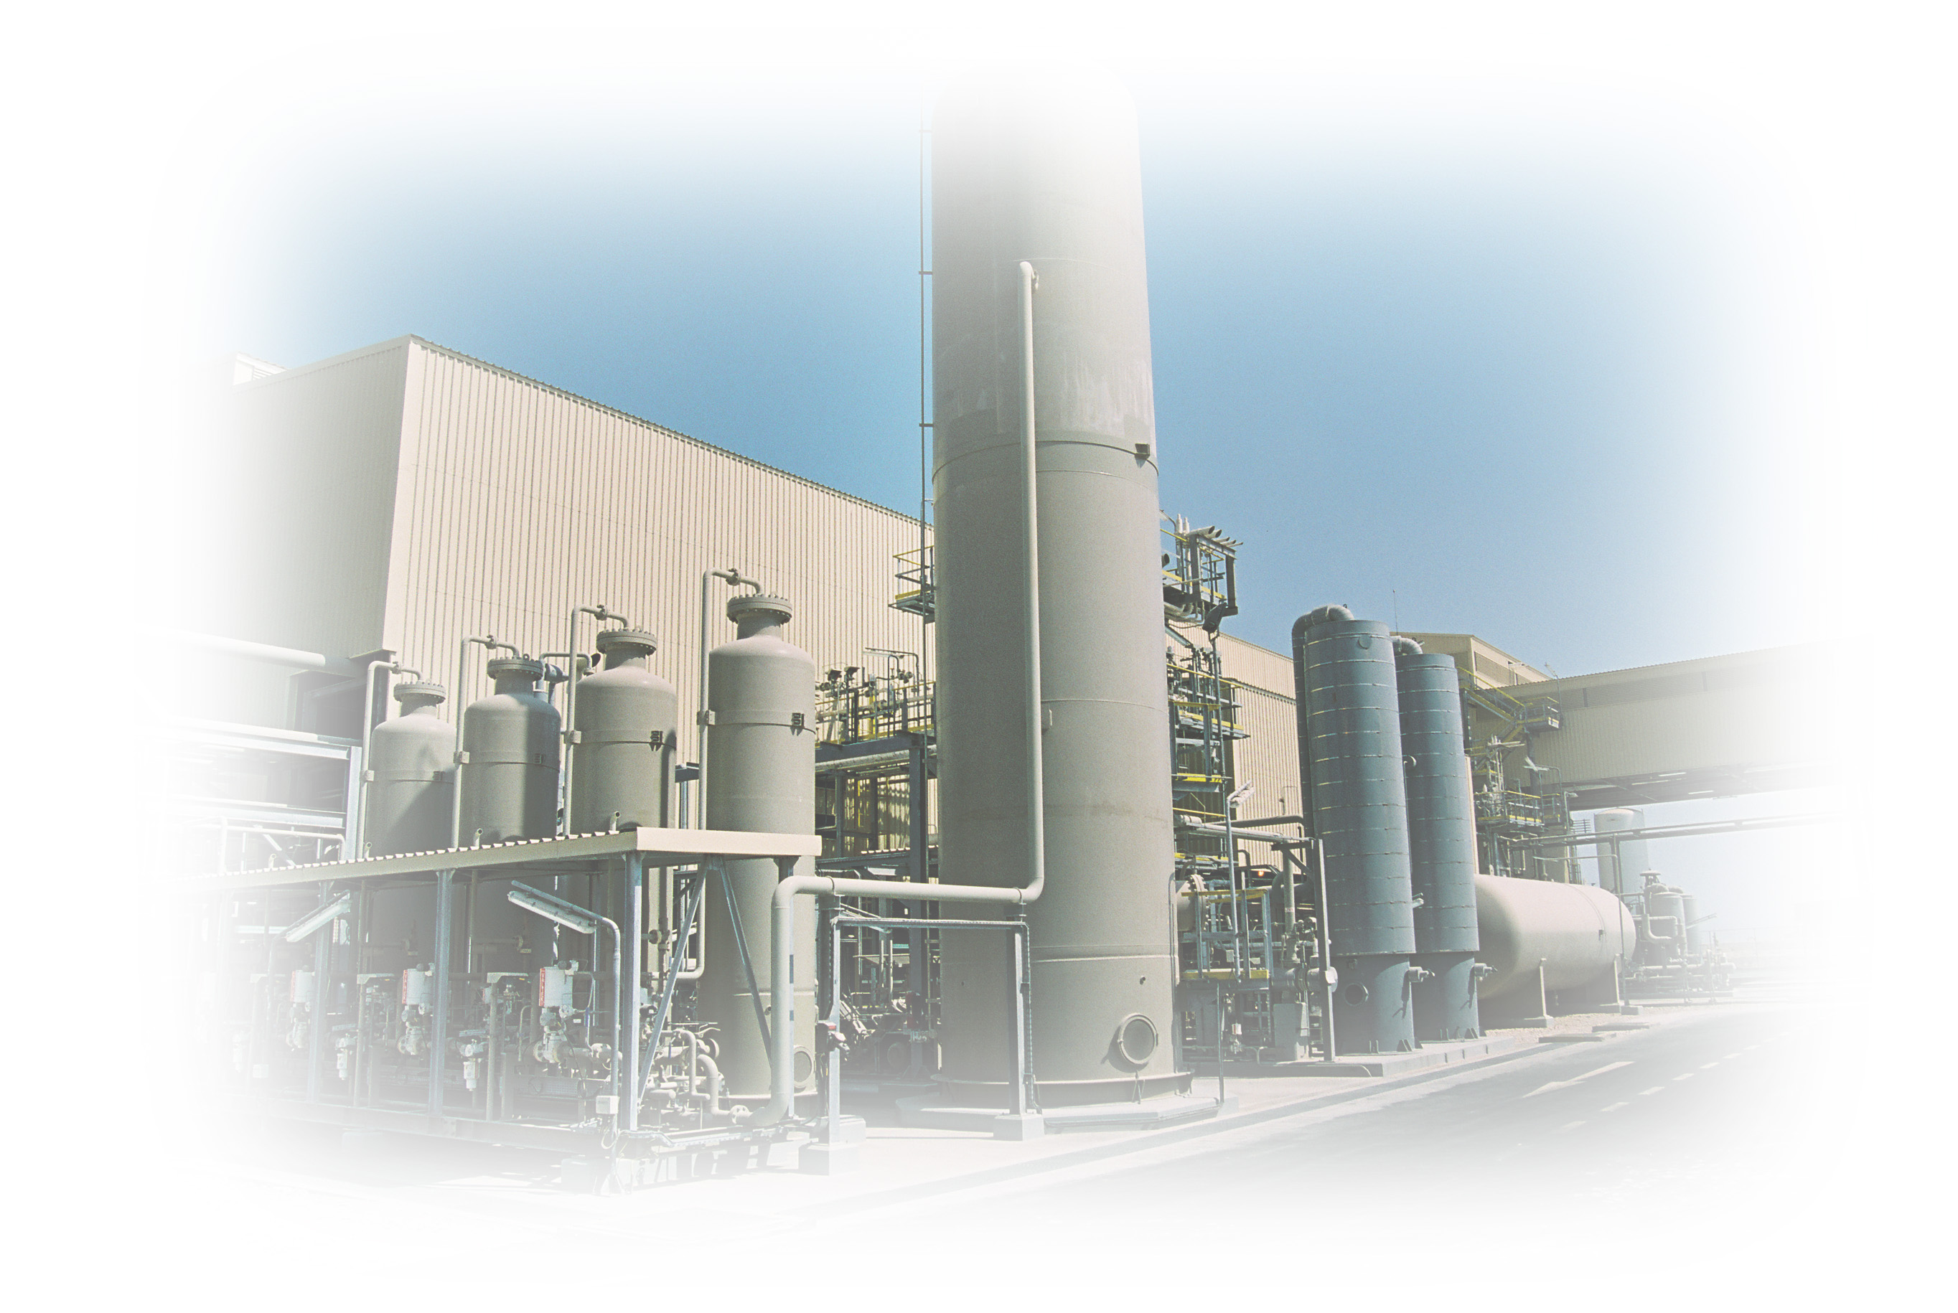
Training Certificate
Awarded to

For successfully completing the
Helium Operators Familiarization Program
HeRU – Simulation Training

This certificate certifies that Mr _______________ has successfully attended a _ days training course on Helium Liquefaction process conducted by Air Liquide in Ras Laffan , Qatar, for the period of January __ 2013 to January __ 2013

Date : Training Instructors :

