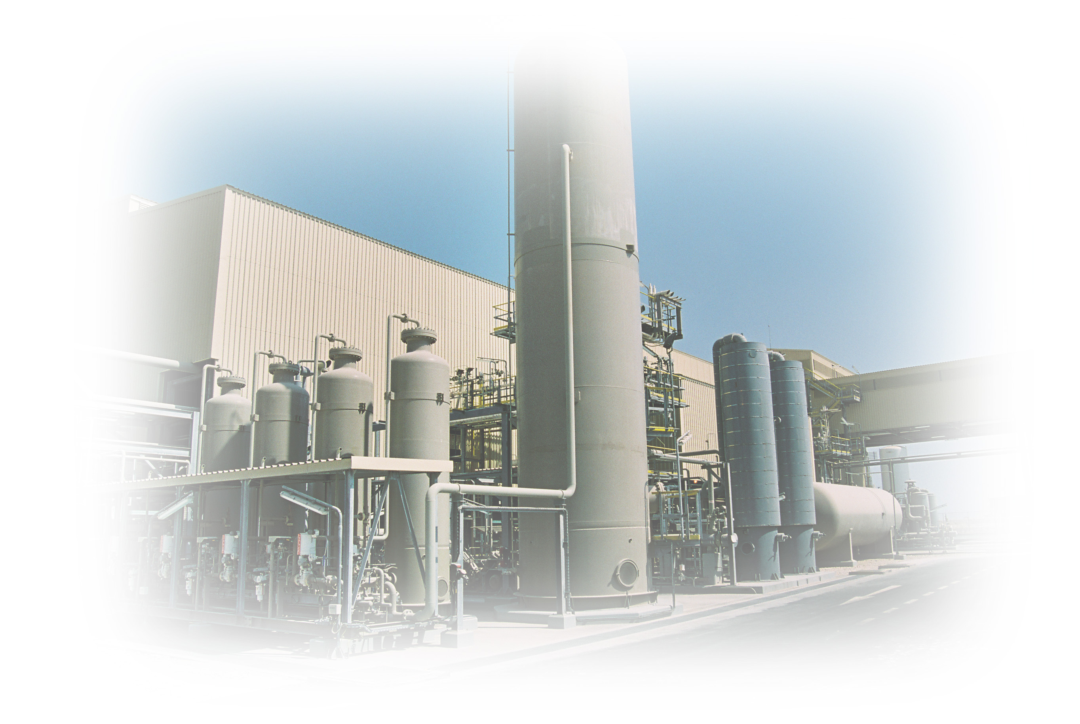
Training Certificate
Awarded to

Nizar Ibrahim

For successfully completing the
Helium Operators Familiarization Program
HeRU – Process Theory

This certificate certifies that Mr Nizar Ibrahim has successfully attended a 3 days training course on Helium Liquefaction process conducted by Air Liquide in Ras Laffan , Qatar, for the period of December 4th, 2012 to December 6th 2012
Vincent HELOIN
Audrey SCHULLER
December 7’th, 2012 Training Instructors :

